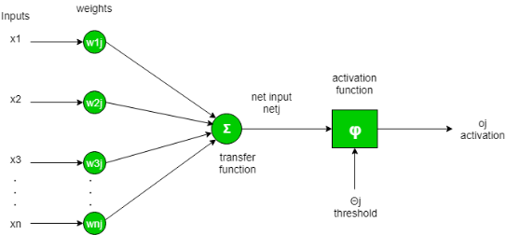 **ACTIVATION FUNCTION**

An activation function is a function that is applied to the output of a neuron in a neural network.

It determines whether the neuron will be activated or not. The picture shows the transfer function doing summation all the inputs then it provides that to the activation function.

Activation function use thresholds to find the decision.

EXAMPLE (If threshold is 0.5 the output 0.7 says activate the network,0.2 tells don’t activate the neural network)

**TYPES OF ACTIVATION FUNCTIONS**

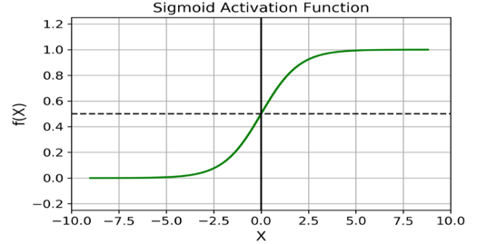 1.SIGMOID FUNCTION

* **Equation:**A = 1/ (1 + e-x)
* **Value Range:**0 to 1
* **Uses:** where result is either 0 or 1, as value for sigmoid function lies

between 0 and 1 only so, result can be predicted easily to be ***1*** if value

is greater than **0.5** and ***0*** otherwise.

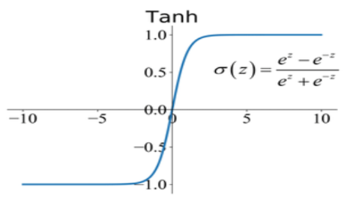

2. TANH FUNCTION

* **Equation: tanh(x) = (e^x - e^(-x)) / (e^x + e^(-x))**
* **Value Range:**-1 to +1
* **Uses:** Usually used in hidden layers of a neural network as its values

lies between **-1 to 1**

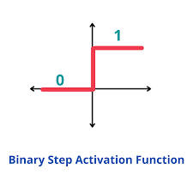

3. STEP FUNCTION

* **Equation:**f(x) = 1 if x > threshold, f(x) = 0 if x <= threshold
* **Value Range:**INFINITY
* **Uses:** outputs 1 if the input is greater than a certain threshold, and 0

if the input is less than or equal to the threshold.

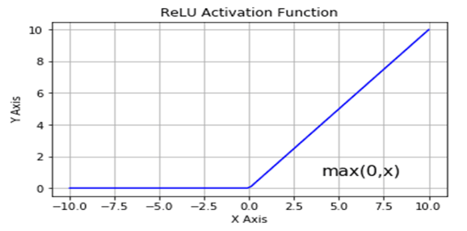 4. RELU FUNCTION

* **Equation:  *A(x) = max (0, x)***. It gives an output x if x is positive and 0 otherwise.
* **Value Range:**0 TO INFINITY
* **Uses:** y=-1 is in the output 0 and y=1 is in the output of 1

(y=4 ,x=1 output is 0 // y=5,x=8 output is 1)

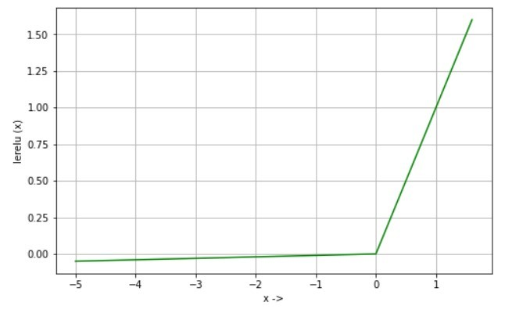 5. LEAKY RELU FUNCTION

* **Equation**: lerelu(x) = x if x>0

lerelu(x) = 0.01 * x if x<=0

* **Value Range:**0 TO INFINITY
* **Uses:** Relu return 0 if the input is negative and hence the neuron becomes

inactive as it does not contribute to gradient flow. Leaky Relu overcomes this

problem by allowing small value to flow when the input is negative.